Chapter 35-1

hashing

- Main features of hashing:
- hash table -- where data are stored.
e.g. an array of 100 elements
- hash function – takes a key of an element and returns an integer, called the hash code.
e.g. hf(key)=key*2
- Address computation – takes the hash code returned by the hash function to compute the address of the element in the hash table.
e.g. Let x be the hash code and n the table size. A simple address assignment is |x|%n.

//Example 35-1-1
Assume positive integer key, hash table of size 7, hf(key)=key, address assignment |key|%7
Insert 22.

Insert 4.

Search for 22.

Collision

- Consider inserting 36. We have a collision.
- Can we avoid collision? Technically yes.
  - Use a hash table that has a reserved slot for each possible key.
  - The hf simply returns the key
  - The address scheme uses the key as the address.
This scheme is known as the perfect hashing scheme, which produces no collision.
- In general, the perfect hashing scheme is not practical to implement.
- Thus in practice, we cannot avoid collision. So, we want to minimize collision.
  - A large size table would help.
  - We need to design a good hashing function with 2 properties:
- Evaluation of hash function should be efficient.
- The hash function must produce uniformly distributed hash codes.

Method hashCode

- Class Object defines method hashCode to perform the hash code calculation:
public int hashCode()
The implementation of this general hashCode method converts the internal address of an object into an integer value. This has limited application because

//Example 35-1-2
public class Demo
{
public static void main(String[] args)
{
Time24 t1= new Time24(2, 30);
Time24 t2= new Time24(2, 30);
System.out.println("hash code for "+ t1+" is "+t1.hashCode());
System.out.println("hash code for "+ t2+" is "+t2.hashCode());
}
}
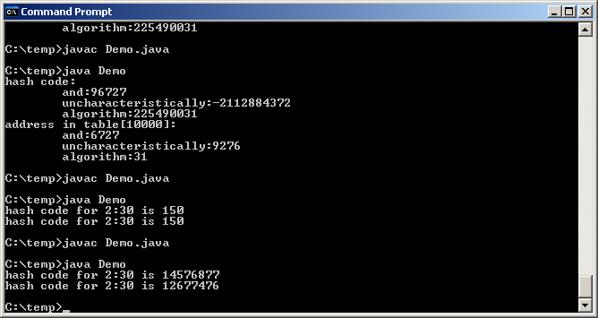

//Example 35-1-3
public class Demo
{
public static void main(String[] args)
{
String s1= new String("john");
String s2= new String("john");
Integer n1= new Integer (36);
Integer n2= new Integer (36);
Double f1= new Double (36.0);
Double f2= new Double (36.0);
System.out.println("hash code for s1 "+s1.hashCode());
System.out.println("hash code for s2 "+s2.hashCode());
System.out.println("hash code for n1 "+n1.hashCode());
System.out.println("hash code for n2 "+n2.hashCode());
System.out.println("hash code for f1 "+f1.hashCode());
System.out.println("hash code for f2 "+f2.hashCode());
}
}
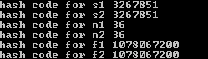

Integer hash functions

- The Java Integer class implements the instance method hashCode by the identity function.
public int hashCode()
{
return value;
}
- If all of the integer key is random, the identity function is a good hf. Otherwise, it can produce many collisions.
- If the integer key is not random, we would require a hash function that mixes up the digits in the key.

//Example 35-1-4
public class Demo
{
public static void main(String[] args)
{
int k1= 10102009;
int k2= 75482009;
System.out.println("hash code for "+k1+" is "+hashCode(k1));
System.out.println("hash code for "+k2+" is "+hashCode(k2));
}
public static int hashCode(int key)
{
long hashValue= key;
hashValue*= hashValue;
return (int)( hashValue% Integer.MAX_VALUE);
}
}
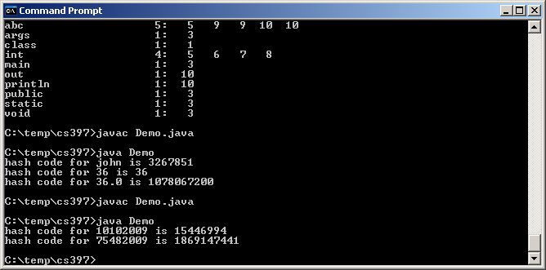

String hash functions

- The Java String class implements the instance method hashcode by the following:
public int hashCode()
{
int hashValue =0;
for (int i=0; i< s.length; ++i)
hashValue = hashValue *31+ this.charAt(i);
return hashValue;
}

//Example 35-1-5
public class Demo
{
public static void main(String[] args)
{
String msg1= new String("and");
String msg2= new String("uncharacteristically");
String msg3= new String("algorithm");
System.out.println("hash code:");
System.out.println("\t"+msg1+":"+msg1.hashCode());
System.out.println("\t"+msg2+":"+msg2.hashCode());
System.out.println("\t"+msg3+":"+msg3.hashCode());
}
}
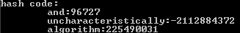

//Example 35-1-6
public class Demo
{
public static void main(String[] args)
{
String msg1= new String("and");
String msg2= new String("uncharacteristically");
String msg3= new String("algorithm");
System.out.println("hash code:");
System.out.println("\t"+msg1+":"+msg1.hashCode());
System.out.println("\t"+msg2+":"+msg2.hashCode());
System.out.println("\t"+msg3+":"+msg3.hashCode());
System.out.println("address in table[10000]:");
System.out.println("\t"+msg1+":"+
((msg1.hashCode())&Integer.MAX_VALUE)%10000);
&&
&
0ddddddddddddddddddd
1ddddddddddddddddddd
sddddddddddddddddddd & 0111111111111 = 0ddddddddddd
System.out.println("\t"+msg2+":"+
((msg2.hashCode())&Integer.MAX_VALUE)%10000);
System.out.println("\t"+msg3+":"+
((msg3.hashCode())&Integer.MAX_VALUE)%10000);
}
}
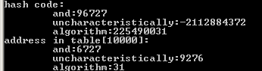

Time24 hash functions

- Add the following method to class Time24:
public int hashCode()
{
return hour*60+minute;
}

//Example 35-1-7
public class Demo
{
public static void main(String[] args)
{
Time24 t1= new Time24(2, 30);
Time24 t2= new Time24(4, 10);
Time24 t3= new Time24(4, 10);
System.out.println("hash code for "+ t1+" is "+t1.hashCode());
System.out.println("hash code for "+ t2+" is "+t2.hashCode());
System.out.println("hash code for "+ t3+" is "+t3.hashCode());
}
}
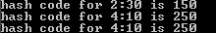

Designing hash tables

- It does not matter how good the hash function is, there will be collisions.
- We must decide 2 things:
- How to resolve collision -- linear probing or chaining
- Table size – table size should be prime which would minimize collisions; the actual size depends on collision resolution method. For linear probing, table size should be at least 2*(number of elements). For chaining, table size should be at least (number of elements)/2.

Linear probing

- The insert algorithm does the following steps:
  - Given the key, computes the hash code, then computes the table index from the hash code.
  - If slot is open, key is inserted. If collision, begins a linear search starting from the next index looking for the first open slot treating the table as circular. Insertion occurs at the first open location.

//Example 35-1-8
Assume table of size 11, identity hash function. Insert 54, 77, 94, 89, 14, 45, 35, 76 into the table.
77 89 45 14 35 76 94 ? ? ? 54
Average: 2.1 probes

- Advantages:
- If table size is large relative to the number of items to store, linear probing works well since a good hf generates indices that are evenly distributed over the table range and collision will be minimal.
- Disadvantages:
- As the ratio of table size to the number of items approaches 1, inherent difficulties with the process becomes apparent.
- Insertions and deletions are difficult.

Chaining with separate lists

- A more common approach to hashing defines the hash table as an array of containers. Each container, called a bucket, holds a set of items (usually a linked list) that hash to the same table location.

//Example 35-1-9
A bucket is a singly linked list. Each node in the linked list has 2 fields, value and next.
Using chaining, let us repeat the previous example and Insert 54, 77, 94, 89, 14, 45, 35, 76

[77] [45, 89] [35] [14] ? ? [94] ? ? ? [76, 54]

Average: 1.25 probes

Linear probing vs chaining

- Chaining is generally better than linear probe:
- If table size is at least (number of items)/2, the average size of a linked list is 2. So insertion/search is O(1).
- Searching keys only involves searching the items that hash to the same table location.
- Number of elements not limited by table size, but by memory.
- Delete is simple, just delete.
- Chaining is the most commonly used design for a hash table.

Unordered associative containers

- A binary search tree is an ordered associative container. Maps and sets implemented using BSTree are ordered associative containers.
- Associative container is one you access by key, not index.
- A hash table is an unordered associative container since its elements are not stored in sorted order. Maps and sets implemented using hash table are unordered associative containers.

Rehashing

- When using chaining with separate lists, the number of elements is not limited by the size of the hash table. However, the individual linked lists increase in length, which increases the search time for elements in a list. We can solve this problem by using a strategy called rehashing.
- When the number of elements in the current hash table is a specified percentage of the table size, we create a larger hash table. Elements from the old table are hashed into the new table. The new table will provide better performance until it begins to fill up, at which time we apply rehashing again.

Class Hash<T>

- The hash table conceptually looks like the following:

table[0]
value hashValue
value hashValue

table[1]
value hashValue

table[2]

……
table[n-1]
value hashValue

- When the number of elements in the table >=tableThreshold, a rehash occurs. We define tableThreshold to be (table size*MAX_LOAD_FACTOR). The value of 0.75 for MAX_LOAD_FACTOR is a good value.
- Table size should be prime, but it is difficult to implement. Thus, we will simply use a table size that is odd. We will start with 17. The rehash operation will double the current table size and then add 1.
- Note: We do this because finding the next prime number is difficult.

//Example 35-1-10
/*
public class Hash<T> implements MyCollection<T>, Iterable<T>, java.io.Serializable
Supports a collection of objects with no duplicates in a hash table, with initial size 17. The table grows as rehashing occurs. Type T must provide method hashCode.

Usage: public Hash();
Post: Hash table initialized to empty with size 17.

Usage: public String toString ()
Return: A comma-separated list of elements enclosed in square brackets. This list is not ordered.
*/
import java.util.Iterator;
import java.util.NoSuchElementException;
public class Hash<T> implements MyCollection<T>, Iterable<T>, java.io.Serializable
{
private class Entry<T>
{
private T value;
private int hashValue;
private Entry<T> next;
public Entry(T value, int hashValue, Entry<T> next)
{
this.value = value;
this.hashValue = hashValue;
this.next = next;
}
}

private Entry<T>[] table;
private int numElements;
private final double MAX_LOAD_FACTOR = .75;
private int tableThreshold;

// add needs to check if the num of elements is bigger than tableThreshold and rehash

private void rehash(int newTableSize)
{
Entry<T>[] newTable = new Entry[newTableSize];
Entry<T> entry, nextEntry;
int index;
for (int i=0; i < table.length; i++)
{
entry = table[i];
if (entry != null)
{
table[i] = null;
do
{
nextEntry = entry.next;
index = entry.hashValue % newTableSize;
entry.next = newTable[index]; //insert front
newTable[index] = entry;
entry = nextEntry;
} while (entry != null);
}
}
table = newTable;
tableThreshold = (int)(table.length * MAX_LOAD_FACTOR);
}
public Hash()
{
table = new Entry[17];
numElements = 0;
tableThreshold = (int)(table.length * MAX_LOAD_FACTOR);
}
public int size()
{
return numElements;
}
public boolean add(T item)
{
int hashValue = item.hashCode() & Integer.MAX_VALUE;
int index = hashValue % table.length;
Entry<T> entry = table[index];
while (entry != null)
{
if (entry.value.equals(item)) return false;
entry = entry.next;
}
entry =new Entry<T>(item, hashValue, table[index]);
table[index] = entry;
numElements++;
if (numElements >= tableThreshold) rehash(2*table.length+1);
return true;
}
public void clear()
{
for (int i=0;i < table.length;i++)
table[i] = null;
numElements = 0;
}
public boolean isEmpty()
{
return numElements == 0;
}
public boolean contains(Object item)
{
int index = (item.hashCode() & Integer.MAX_VALUE) % table.length;
Entry<T> entry = table[index];
while (entry != null)
{
if (entry.value.equals(item)) return true;
entry = entry.next;
}
return false;
}
public boolean remove(Object item)
{
int index = (item.hashCode() & Integer.MAX_VALUE) % table.length;
Entry<T> curr = table[index];
Entry<T> prev = null;
while (curr != null)
if (curr.value.equals(item))
{
if (prev != null) prev.next = curr.next;
else table[index] = curr.next;
numElements--;
return true;
}
else
{
prev = curr;
curr = curr.next;
}
return false;
}
public Object[] toArray()
{
Object[] arr = new Object[numElements];
Iterator<T> iter = iterator();
int i = 0;
while (iter.hasNext())
{
arr[i] = iter.next();
i++;
}
return arr;
}
public String toString()
{
Iterator<T> iter = iterator();
String s = "[";
for (int i=0; i<numElements; ++i)
{
s+= iter.next();
if (i<numElements-1) s+=", ";
}
s+= "]";
return s;
}
public Iterator<T> iterator()
{
return new HashIterator();
}
private class HashIterator implements Iterator<T>
{
private int index; //the current bucket where nextNode is in
private Entry<T> nextNode;
private T lastReturned;
//Post: index is the first index in table where table[index]!=null; index==table.length if
// table is empty
// nextNode is the first node in table[index] if table is not empty; nextNode==null
// if table is empty
// lastReturned ==null
public HashIterator()
{
if (numElements == 0)
{
nextNode = null;
index = table.length;
}
else
{
index = 0;
while ((nextNode = table[index]) == null)
index ++;
}
lastReturned = null;
}
public boolean hasNext()
{
return nextNode!= null;
}
public T next()
{
if (nextNode == null) throw new NoSuchElementException();
lastReturned = nextNode.value;
Entry<T> n = nextNode.next;
if (n == null)
{
index++;
while (index < table.length && (n = table[index]) == null)
index++;
}
nextNode = n;
return lastReturned;
}
public void remove()
{
if (lastReturned == null) throw new IllegalStateException(
"Iterator call to next() "+"required before calling remove()");
Hash.this.remove(lastReturned);
lastReturned = null;
}
}
}

//Example 35-1-11
import java.util.Iterator;
public class Demo
{
public static void main(String[] args)
{
Hash<Integer> h=new Hash<Integer>();
h.add(10); h.add(30); h.add(20); h.add(50); h.add(40);
System.out.println("Hash table: "+h);
h.remove(30);
System.out.println("Hash table: "+h);
Iterator<Integer> iter= h.iterator();
while (iter.hasNext())
{
Integer n=iter.next();
if (n==40) iter.remove();
}
System.out.println("Hash table: "+h);
}
}
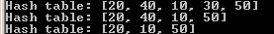

//Example 35-1-12
import java.util.Iterator;
public class Demo
{
public static void main(String[] args)
{
Hash<Time24> h=new Hash<Time24>();
h.add(new Time24(1, 30));
h.add(new Time24(3, 30));
h.add(new Time24(2, 30));
h.add(new Time24(5, 30));
h.add(new Time24(4, 30));
System.out.println("Hash table: "+h);
if (h.contains(new Time24(1, 30))) System.out.println("1:30 is in");
else System.out.println("1:30 is not in");
}
}
